Exercise 1.1:   
OUTPUT:   
   


Exercise 1.2:

OUTPUT:

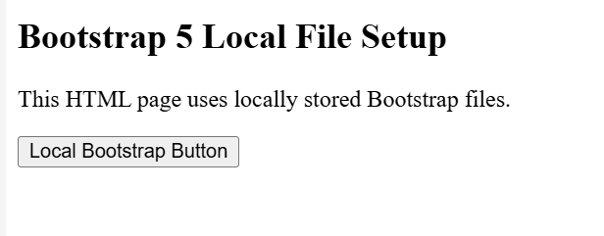

Exercise 2.1 & 2.2:

OUTPUT:

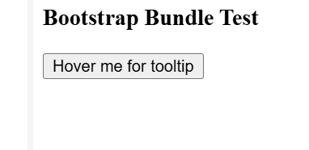

Exercise 3.1 & 3.2:

OUTPUT:

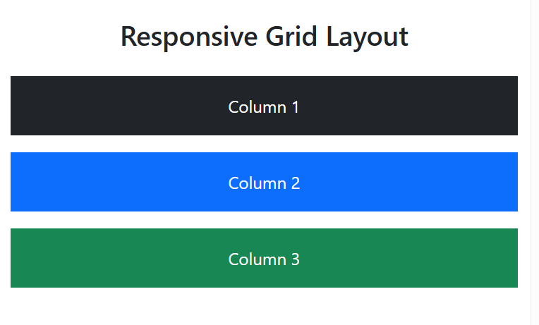

Exercise 4.1 :

OUTPUT:



Exercise 4.2:

OUTPUT:

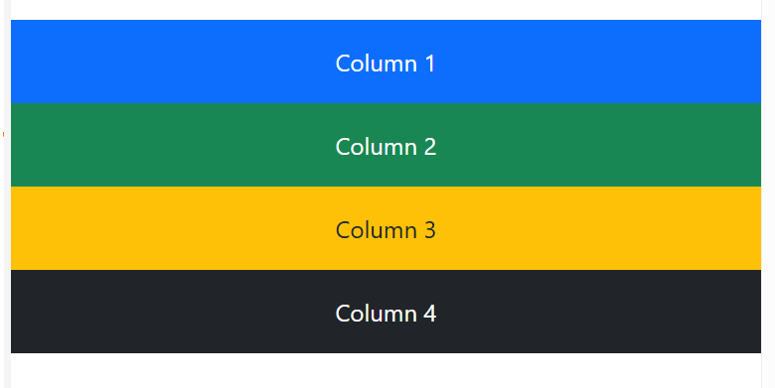

Exercise 5.1 & 5.2:  
OUTPUT:

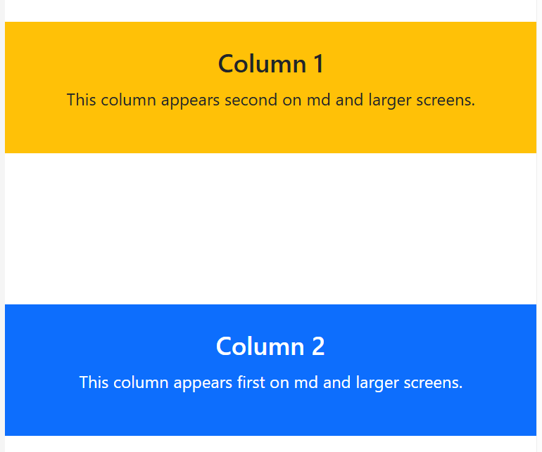

Exercise 6.1 & 6.2:  
OUTPUT:



Exercise 7.1 & 7.2:  
OUTPUT:

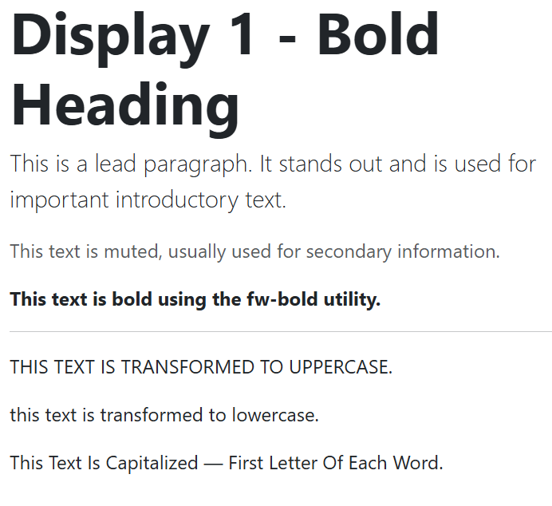

Exercise 8.1 & 8.2:  
OUTPUT:

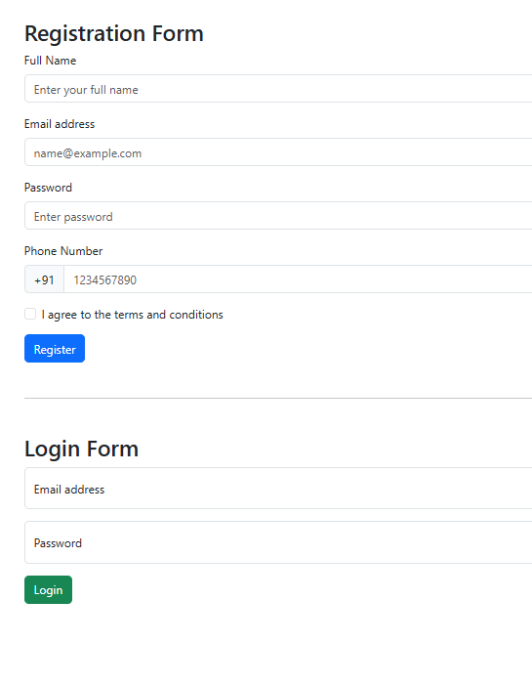

Exercise 9.1 & 9.2:  
OUTPUT:

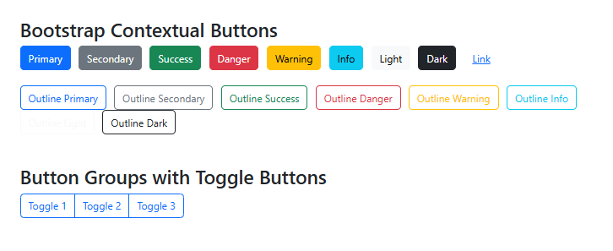

Exercise 10.1 & 10.2:  
OUTPUT:

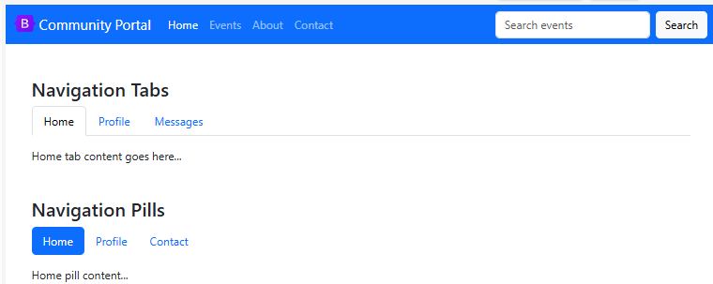

Exercise 11.1 & 11.2:  
OUTPUT:



Exercise 12.1 & 12.2:  
OUTPUT:

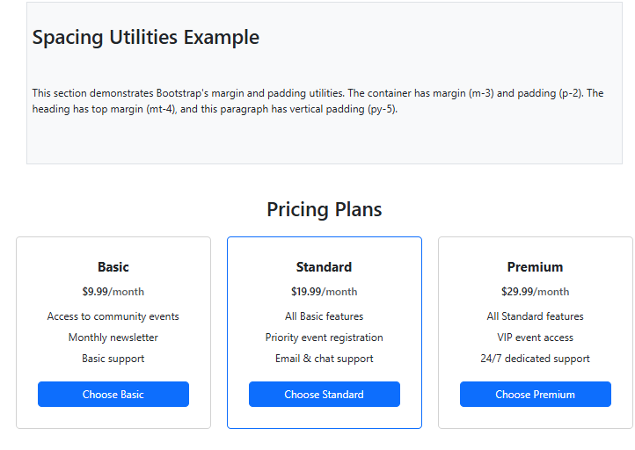

Exercise 13.1 & 13.2:  
OUTPUT:

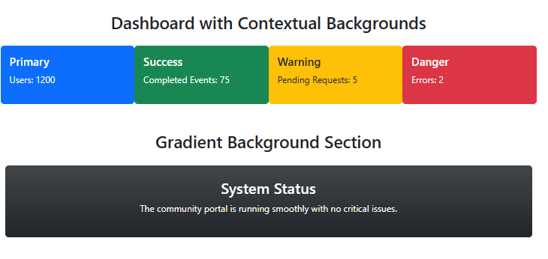

Exercise 14.1 & 14.2:  
OUTPUT:

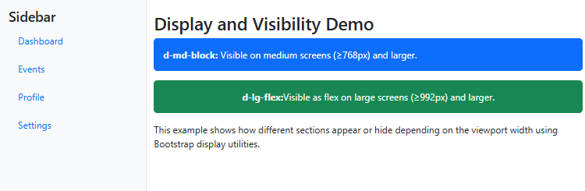

Exercise 15.1 & 15.2:  
OUTPUT:



Exercise 16.1 & 16.2:  
OUTPUT:



Exercise 17.1 & 17.2:

OUTPUT:



Exercise 18.1 & 18.2:

OUTPUT:

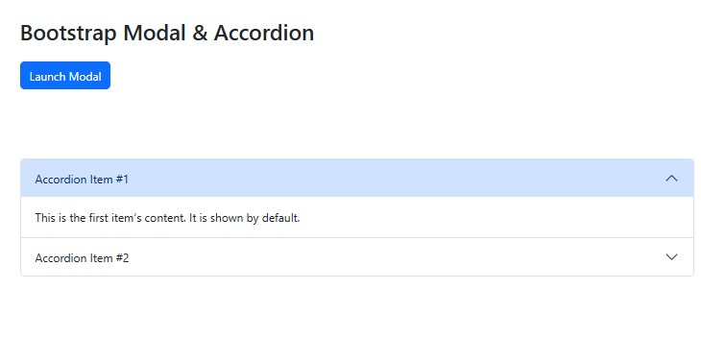

Exercise 19.1 & 19.2:

OUTPUT:

